**Assignment 3**

**User Management**

1. Create user "Nikhil" with home directory set as "/home/Nikhil"  
          a) Nikhil user should have "/bin/sh" shell for his environment

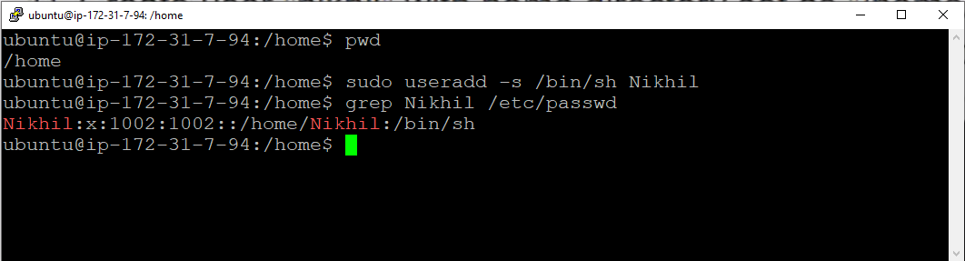

Commands :-

sudo useradd –s /bin/sh Nikhil :- Adding user with login shell

grep Nikhil /etc/passwd :- verify the user with login shell

b) His password should expire in 9 days and 2 days before password expiry, he should get warning. User account must expire in 1 month from creation date.

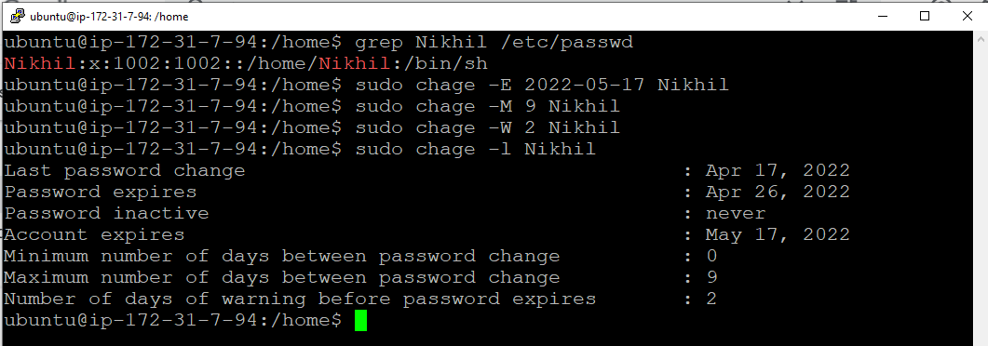

Commands :-

sudo chage -E 2022-05-17 Nikhil :- set user account expiry

sudo chage -M 9 Nikhil :- set user password should expire in 9 days

sudo chage -W 2 Nikhil :- set user get warning 2 days before password expiry.

sudo chage -l Nikhil :- Verify password information

c) Give him root privileges to start/stop cron daemon.



Commands :

sudo su :- using for login with another user

visudo :- using for editing user file, rights.

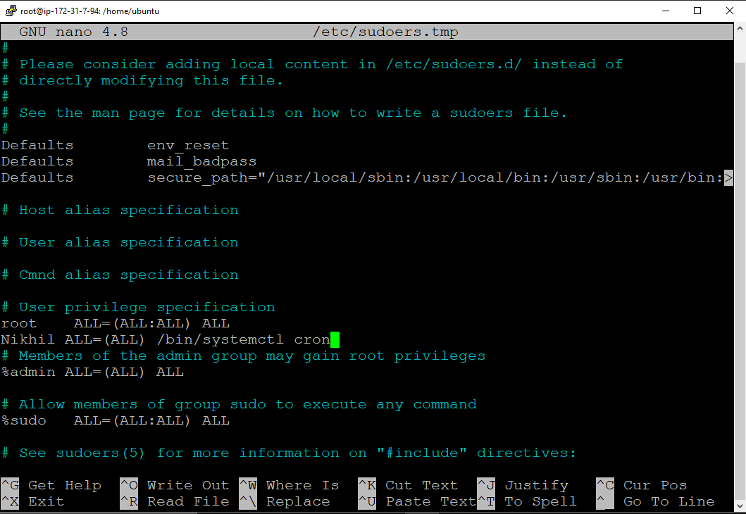

Commands :

Nikhil ALL=(ALL) /bin/systemctl cron :- Give root privilides to Nikhil for cron service

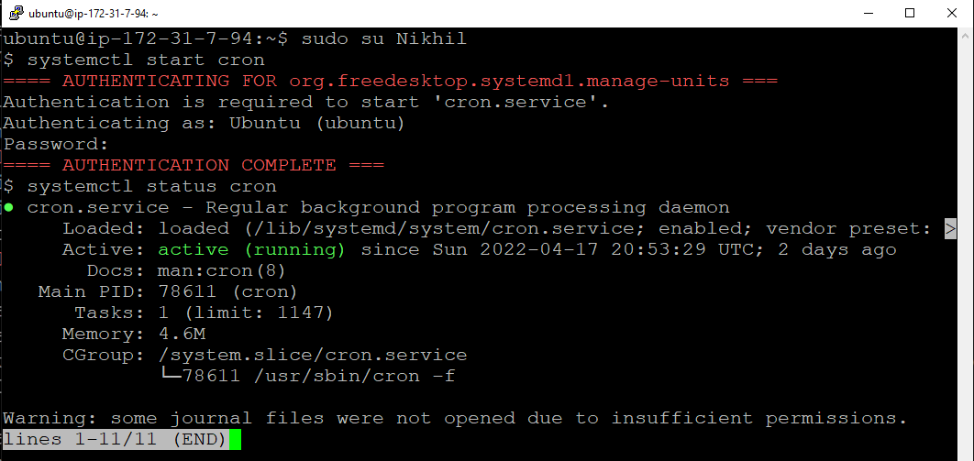

Commands :

sudo su Nikhil :- Log in to user Nikhil

systemctl start cron :- start the cron service

systemctl status cron :- checking status of cron service

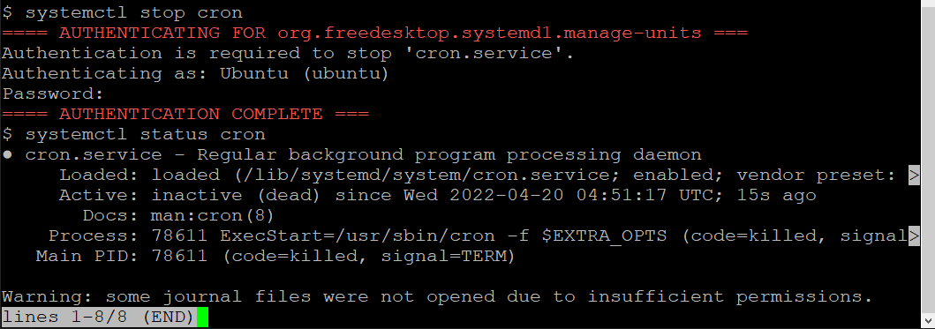

Commands :

systemctl stop cron :- Stop the cron service.

1. Inside folder "/" , create new home directory as "nikhil" (/nikhil) and setup this folder as a home directory for user "Nikhil"

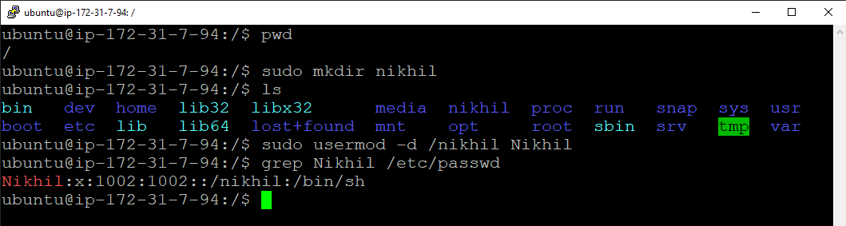 Commands :-

sudo mkdir nikhil :- Making new directory in root folder

sudo usermod –d /nikhil Nikhil :- change the home directory of user Nikhil to /Nikhil.

grep Nikhil /etc/passwd :- Verify the user location